Supplement 4: Models with phylogenetic correction

- Phylogenetic tree used in analysis of development variables

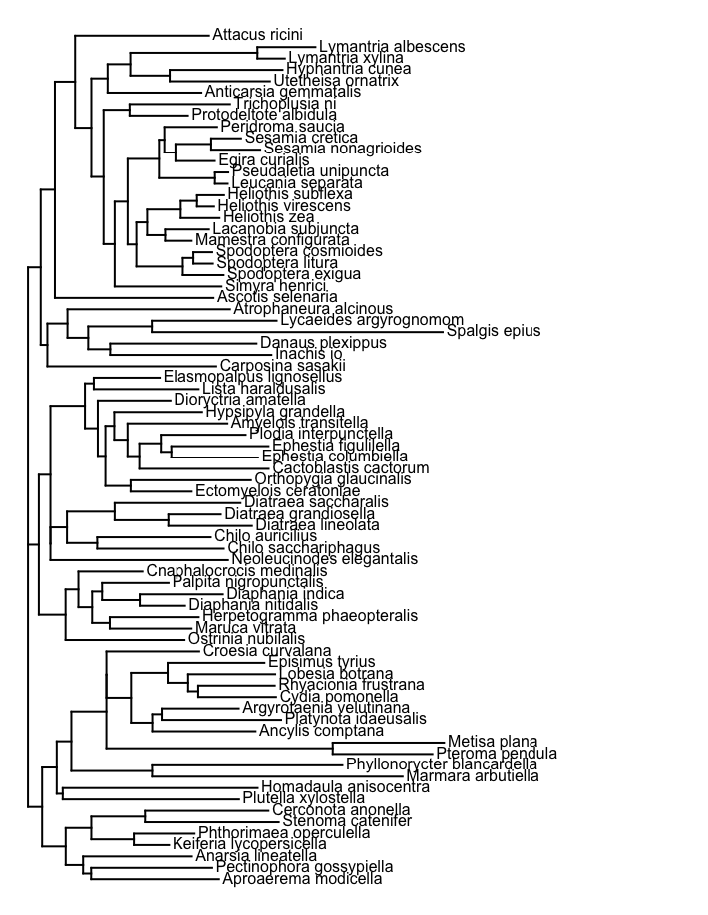

D_{l}
Fixed effects | Estimate | SE | Z score
absolute latitude | -0.087 | 0.0260 | -4.05
egg | 23.5 | 0.896 | 30.04
larva | 23.22 | 0.911 | 29.27
pupa | 23.94 | 0.910 | 30.25
Random effects | SD
species | 0.85
residual | 1.18
N = 167 obs., 71 species

R²_{lik} (phylogenetic vs non-phylogenetic model): 0.0026

D_{h}
Fixed effects | Estimate | SE | Z score
absolute latitude | -0.048 | 0.029 | -1.623
egg | 35.32 | 1.022 | 34.548
larva | 34.97 | 1.010 | 34.651
pupa | 34.91 | 1.011 | 34.514
Random effects | SD
species | 0.004
residual | 1.066
N = 84 obs., 41 species

R²_{lik} (phylogenetic vs non-phylogenetic model): < 0.0001

D_{breadth}
Fixed effects | Estimate | SE | Z score
absolute latitude | 0.031 | 0.025 | 1.276
egg | 12.471 | 0.859 | 14.513
larva | 12.012 | 0.835 | 14.386
pupa | 11.088 | 0.843 | 13.139
Random effects | SD
species | 0.001
residual | 1.226
N = 82 obs., 39 species

R²_{lik} (phylogenetic vs non-phylogenetic model): < 0.0001

- Phylogenetic tree used in T₀ analysis
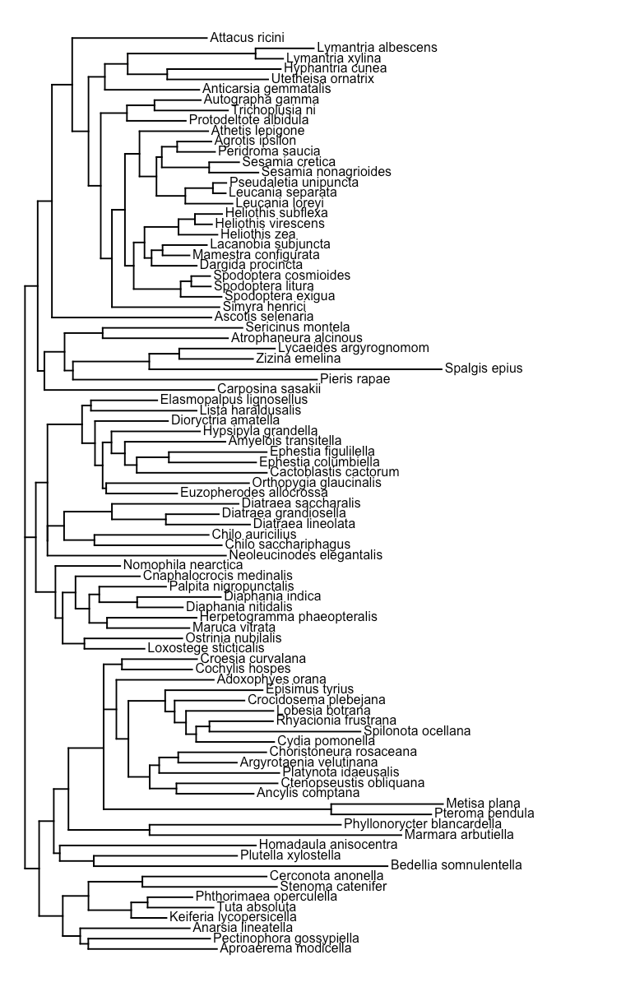

T₀
Fixed effects | Estimate | SE | Z score
absolute latitude | -0.0312 | 0.021 | -1.509
egg | 11.43 | 0.835 | 13.700
larva | 10.72 | 0.844 | 12.700
pupa | 11.63 | 0.830 | 14.011
Random effects | SD
species | 1.30
residual | 1.583
N = 235 obs., 89 species

R²_{lik} (phylogenetic vs non-phylogenetic model): < 0.0001

- Phylogenetic tree used in analysis of survival variables

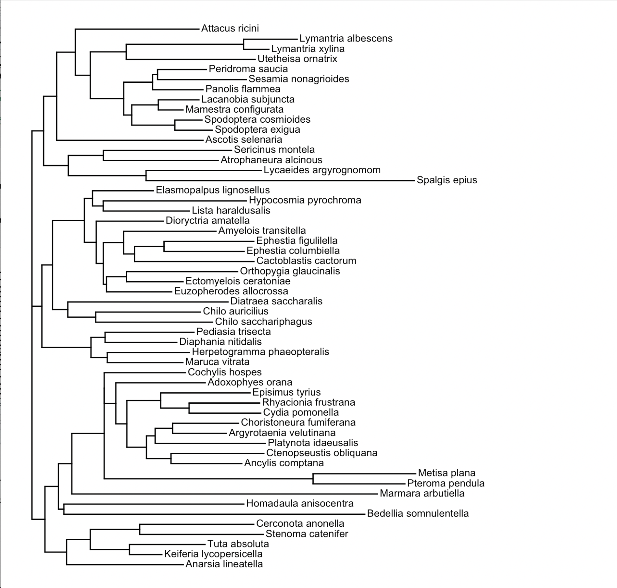

S_{l}
Fixed effects | Estimate | SE | Z score
absolute latitude | -0.258 | 0.053 | -4.837
egg | 23.367 | 1.841 | 12.694
larva | 20.569 | 1.692 | 12.161
pupa | 19.108 | 2.044 | 9.346
Random effects | SD
species | 1.92
residual | 1.75
N = 61 obs., 34 species

R²_{lik} (phylogenetic vs non-phylogenetic model): - 0.02

S_{h}
Fixed effects | Estimate | SE | Z score
absolute latitude | -0.051 | 0.044 | -1.157
egg | 33.710 | 1.603 | 21.026
larva | 33.233 | 1.644 | 20.209
pupa | 33.248 | 1.635 | 20.34
Random effects | SD
species | 1.76
residual | 1.75
N = 65 obs., 36 species

R²_{lik} (phylogenetic vs non-phylogenetic model): 0.003

S_{breadth}
Fixed effects | Estimate | SE | Z score
absolute latitude | 0.121 | 0.087 | 1.381
egg | 13.333 | 3.199 | 4.167
larva | 10.996 | 3.216 | 3.419
pupa | 12.620 | 3.246 | 3.888
Random effects | SD
species | 3.462
residual | 2.415
N = 41 obs., 24 species

R²_{lik} (phylogenetic vs non-phylogenetic model): -0.287

- Phylogenetic tree used in analysis of performance variables

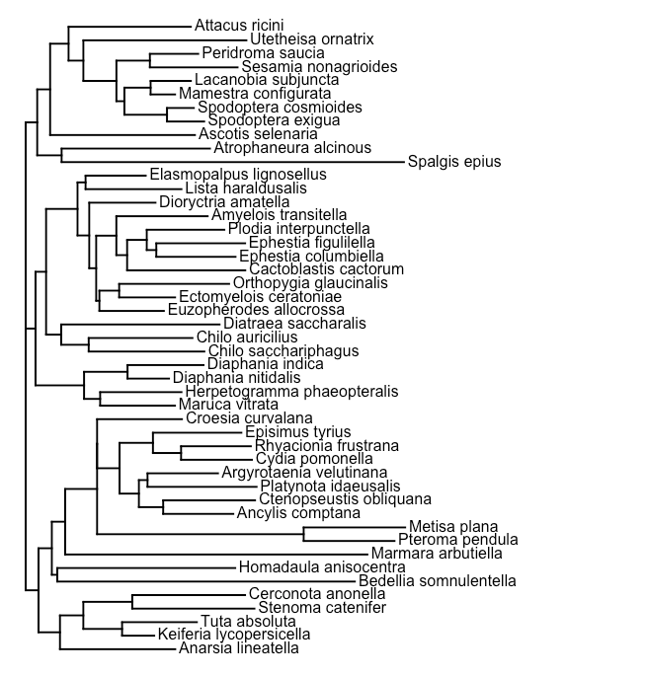

P_{l}
Fixed effects | Estimate | SE | Z score
absolute latitude | -0.109 | 0.036 | -3.069
egg | 24.366 | 1.252 | 19.466
larva | 24.424 | 1.285 | 19.012
pupa | 24.881 | 1.271 | 19.574
Random effects | SD
species | 1.355
residual | 1.646
N = 96 obs., 46 species

R²_{lik} (phylogenetic vs non-phylogenetic model): -0.0263

P_{h}
Fixed effects | Estimate | SE | Z score
absolute latitude | -0.041 | 0.040 | -1.021
egg | 33.979 | 1.383 | 24.56
larva | 33.772 | 1.415 | 23.86
pupa | 33.593 | 1.414 | 23.764
Random effects | SD
species | 1.846
residual | 1.073
N = 62 obs., 36 species

R²_{lik} (phylogenetic vs non-phylogenetic model): 0.023

P_{breadth}
Fixed effects | Estimate | SE | Z score
absolute latitude | 0.016 | 0.037 | 0.442
egg | 11.177 | 1.261 | 8.860
larva | 11.498 | 1.314 | 8.746
pupa | 10.769 | 1.296 | 8.309
Random effects | SD
species | 2.093
residual | 1.589
N = 60 obs., 34 species

R²_{lik} (phylogenetic vs non-phylogenetic model): < 0.0001

