Appendix 1. The study site (a) was located along the San Pedro River, in southeastern, Arizona, USA within the San Pedro Riparian National Conservation Area (SPRNCA). Study sites are shown with black circles. The primary floodplain is in black, the upland riparian zone is grey, and the surrounding desert scrub is white. The study design (b) is based on the juxtaposition of the cottonwood-dominated, primary floodplain (CW), the three categories of upland riparian habitat (GRASS=grassland, MIX=grassland-mesquite mix, and MES=mesquite), and the surrounding desert scrub (DS) results in six combinations of adjacent habitat pairs and twelve edge types since responses were measured on both sides of each edge. No single site had all twelve edge types represented, but most sites had ~4 edge types with 1-3 transects set up for each edge type present. Transects were composed of contiguous 10 x 10 m plots, illustrated for each edge type with the usual length of each transect indicated by the number of boxes spanning the edge.
a.
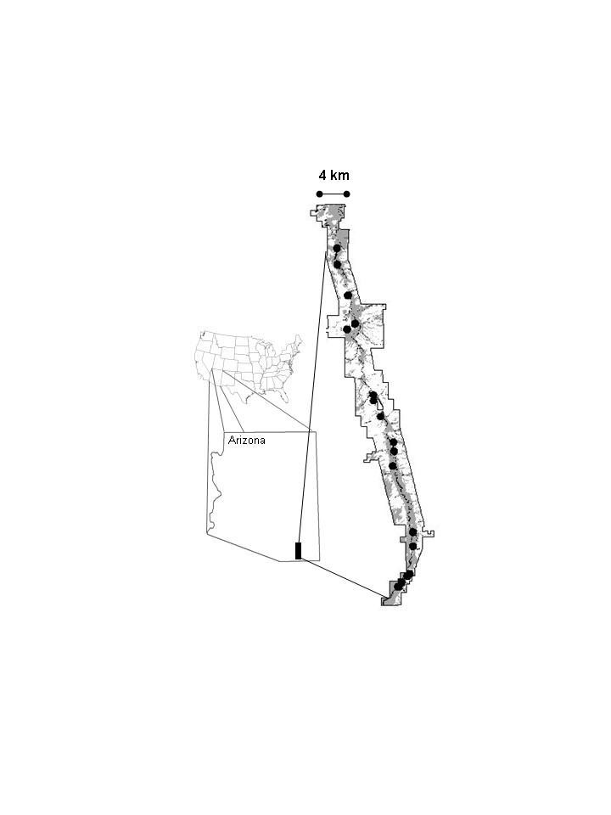

b.
